**Operating Systems**

**(CSL 303)**

Lab Practical Report



Faculty name : Dr. Priyanka Vashisth Student name :Aarushi

Roll No.: 18csu002

Semester:5th

Group:DS-V-A

**Experiment No:2**

Date: 23/08/2020

**Objective:**

Write basic Linux commands.

**Commands:**

# **File Commands**

1. **pwd:**

Description: Show current working directory

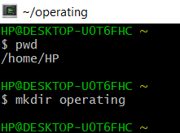

1. **mkdir:**

Description: This command is used create a new directory in a current directory.

Syntax: mkdir <directory name>



1. **ls:**

* **ls:**

Description: shows the files /directories in your current directory.

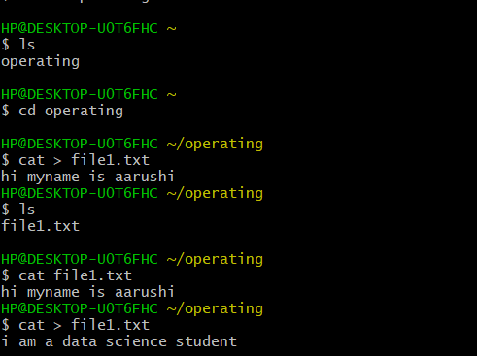

* **ls -a:**

Description:   To view hidden files

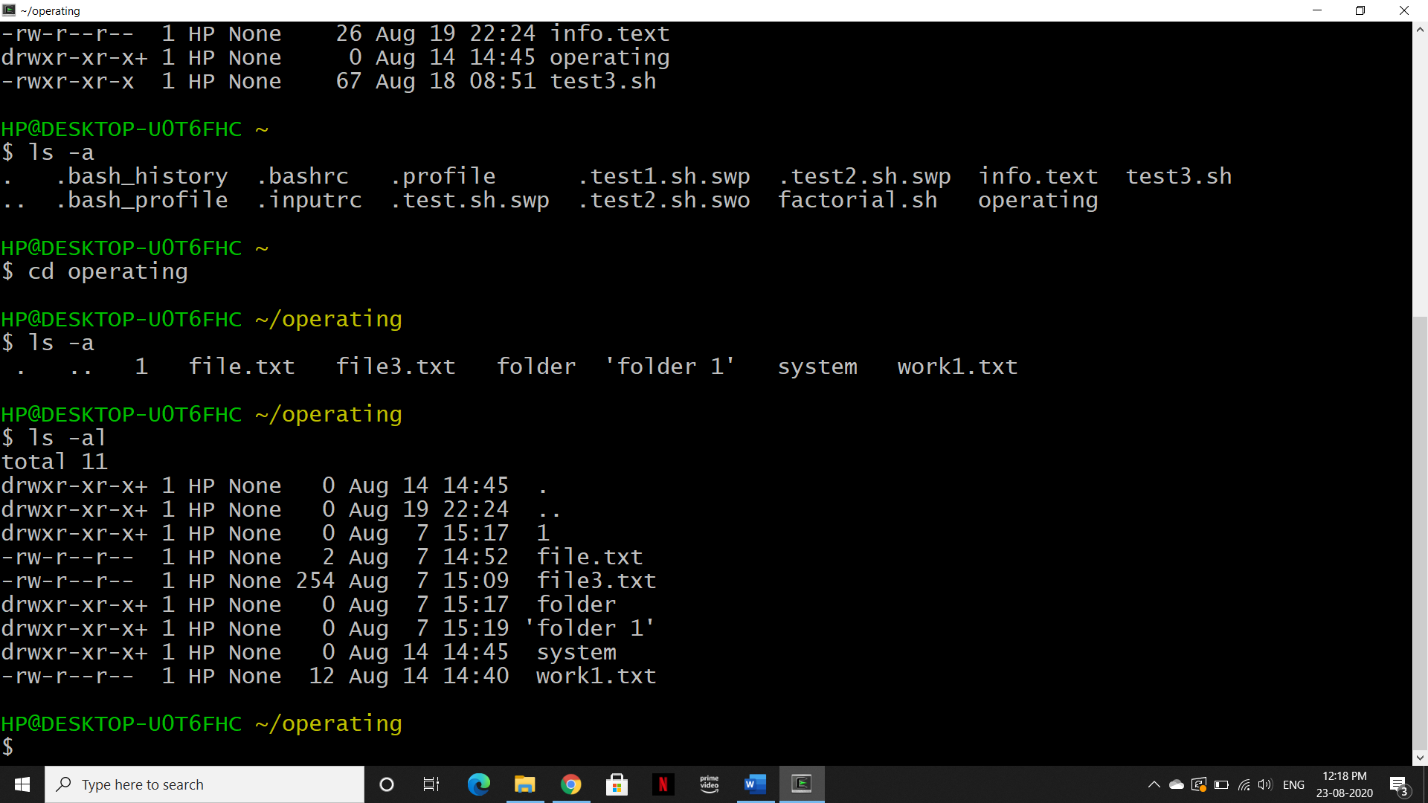

There are no hidden directories/files in our directory (Note: Any Directory/file starting with '.' is hidden)

* **ls -l:**

Description: Gives detailed information of the files

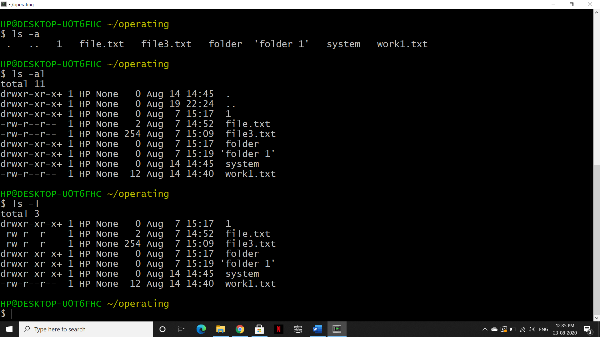

1st Column File type and access permissions

2nd Column # of HardLinks to the File

3rd Column Owner and the creator of the file

4th Column Group of the owner

5th Column File size in Bytes

6th Column Date and Time

7th Column Directory or File name

* **ls -s:**

Description: Display the files in sorted way

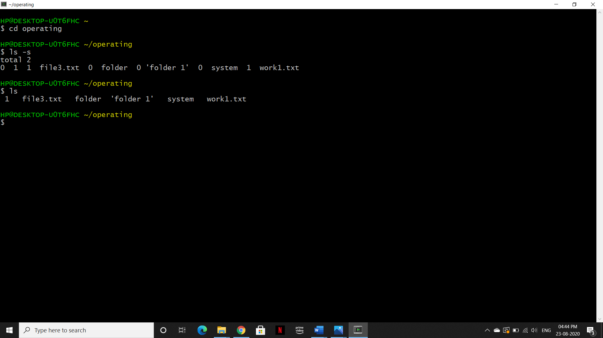

* **ls -ls >filename:**

Description: Store the configuration of ls in filename

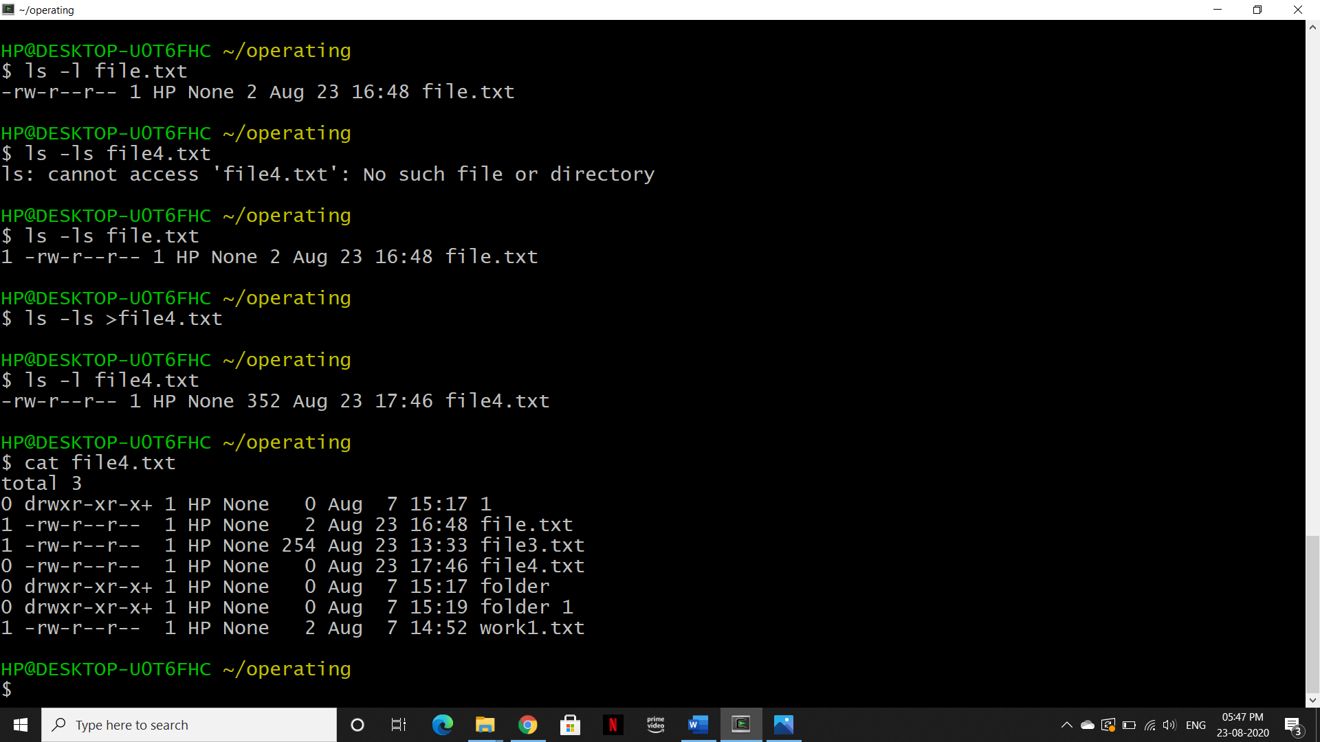

1. **cd:**

* **cd dir**

Description: This command helps us to move to the mentioned directory.

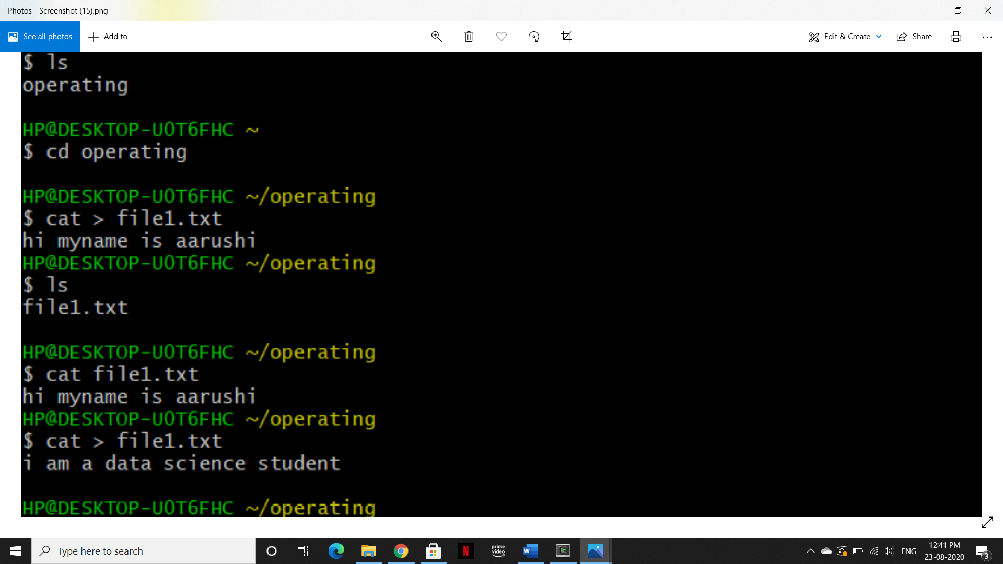

* **cd**

Description: Change to home directory

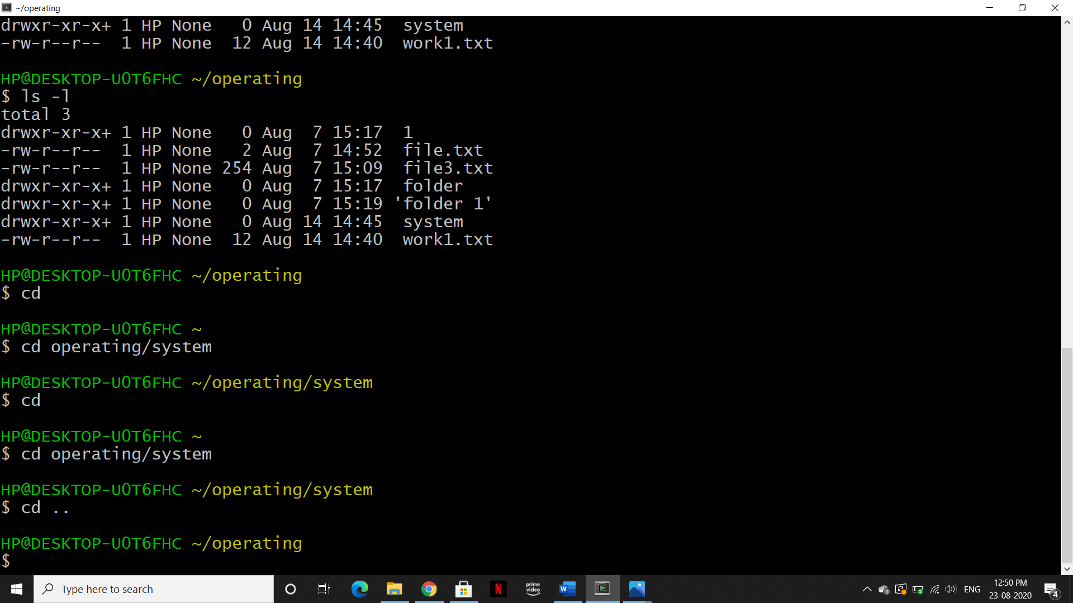

* **cd ..**

Description: change to previous directory



1. **cat:**

* **cat > filename**

Description: Places the standard input into the file

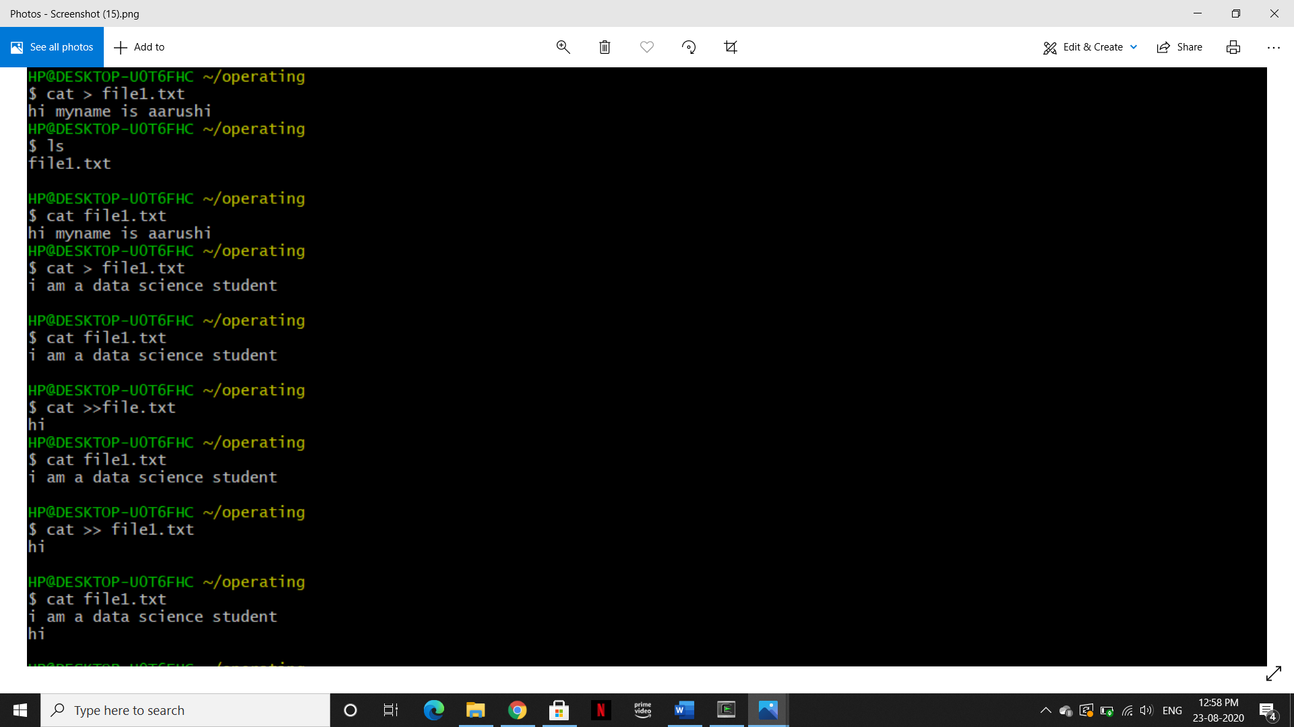

Note: After adding content, Press 'ctrl + d’ to exit

* **cat filename**

Description:To view the content of a file



* **cat >>filename**

Description: to append data in same file

* Before appending data-



Note: the content in file1 get replaced with new content.

* After appending data-



* **Cat filename1 > filename2**

Description: It copies the content of file1 into file2.

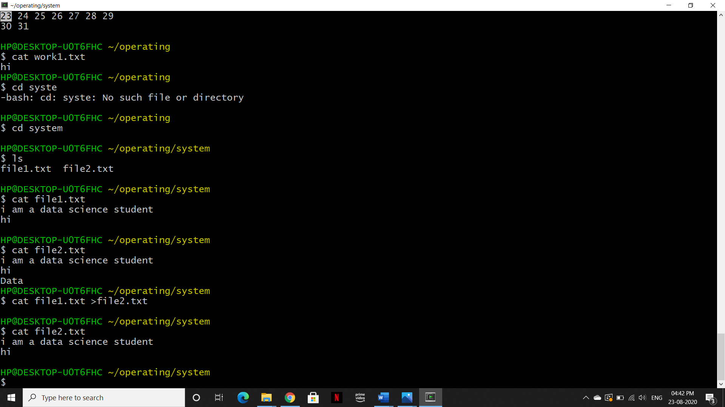

1. **Touch:**

Description: create a file without any content

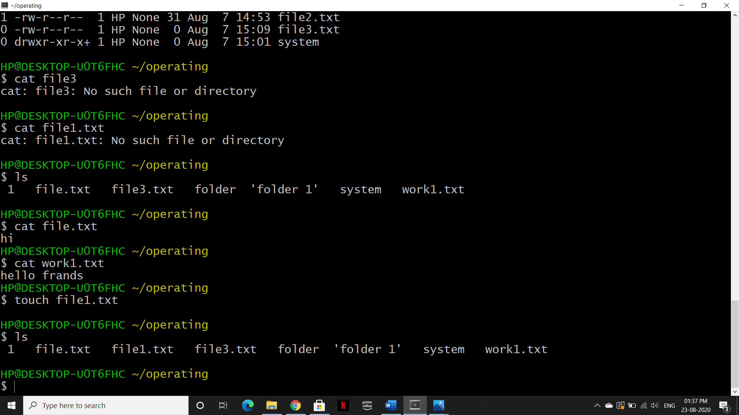

List directory, to check file has been created-

1. **Cp:**

* **cp file1 file2-**

Description: It can copy the content of file1 into file2 without deleting file1.

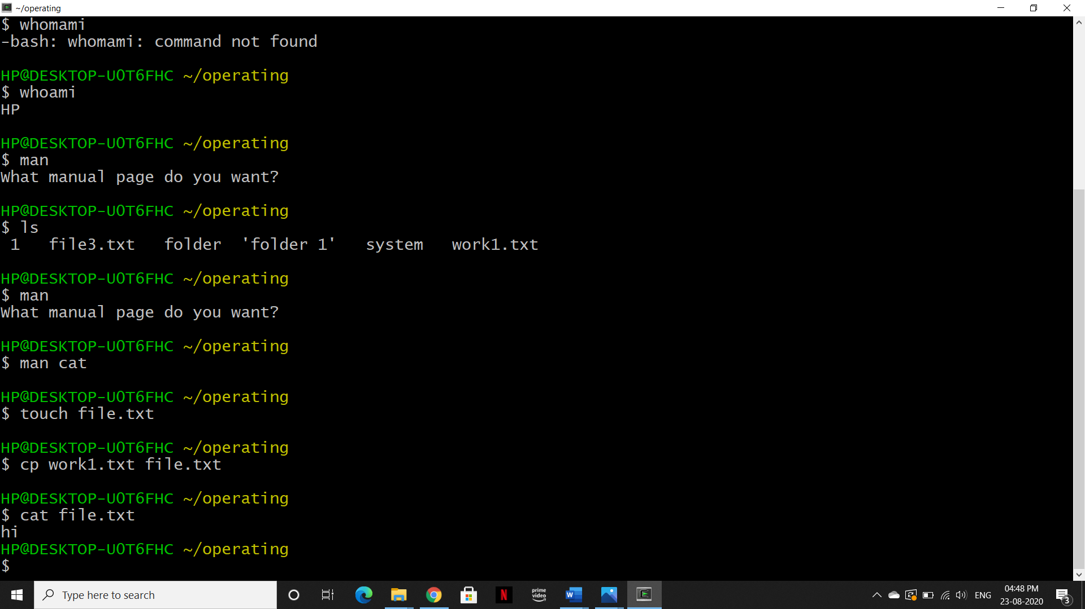

Show the content of file1, to check content has been copied



* **cp -r dir1 dir2**

Description: It can copy dir1 to dir2 and if dir2 not present it creates one.

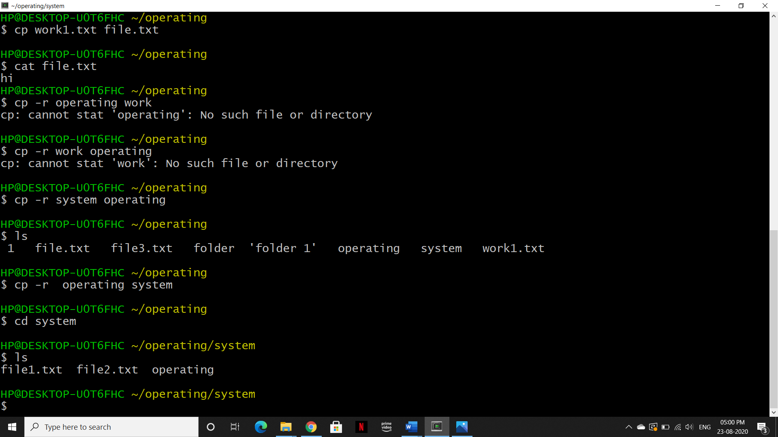

1. **mv:**

* moving file from one directory to another-

Description: This command move the file from source directory to destination directory and after moving ,remove the source file.

Syntax: mv <source filename> <destination directory path>

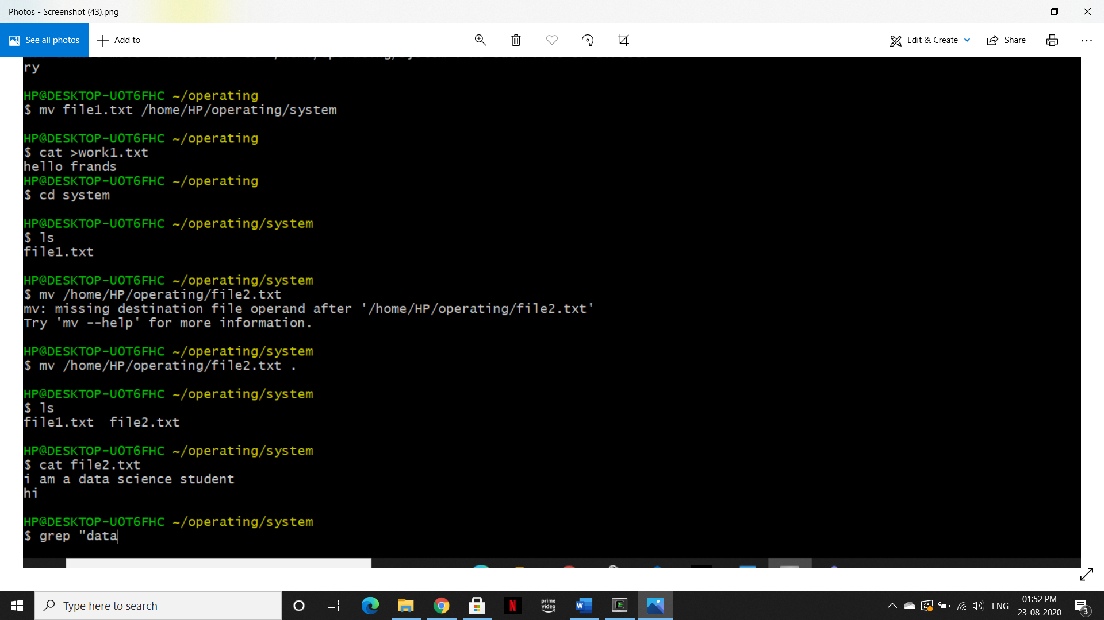

List directory, to check file has been moved-



**OR**



**Note:** Directly from source directory into current directory

* moving file content from source file to destination file –

Syntax: mv <source filename> <destination filename>

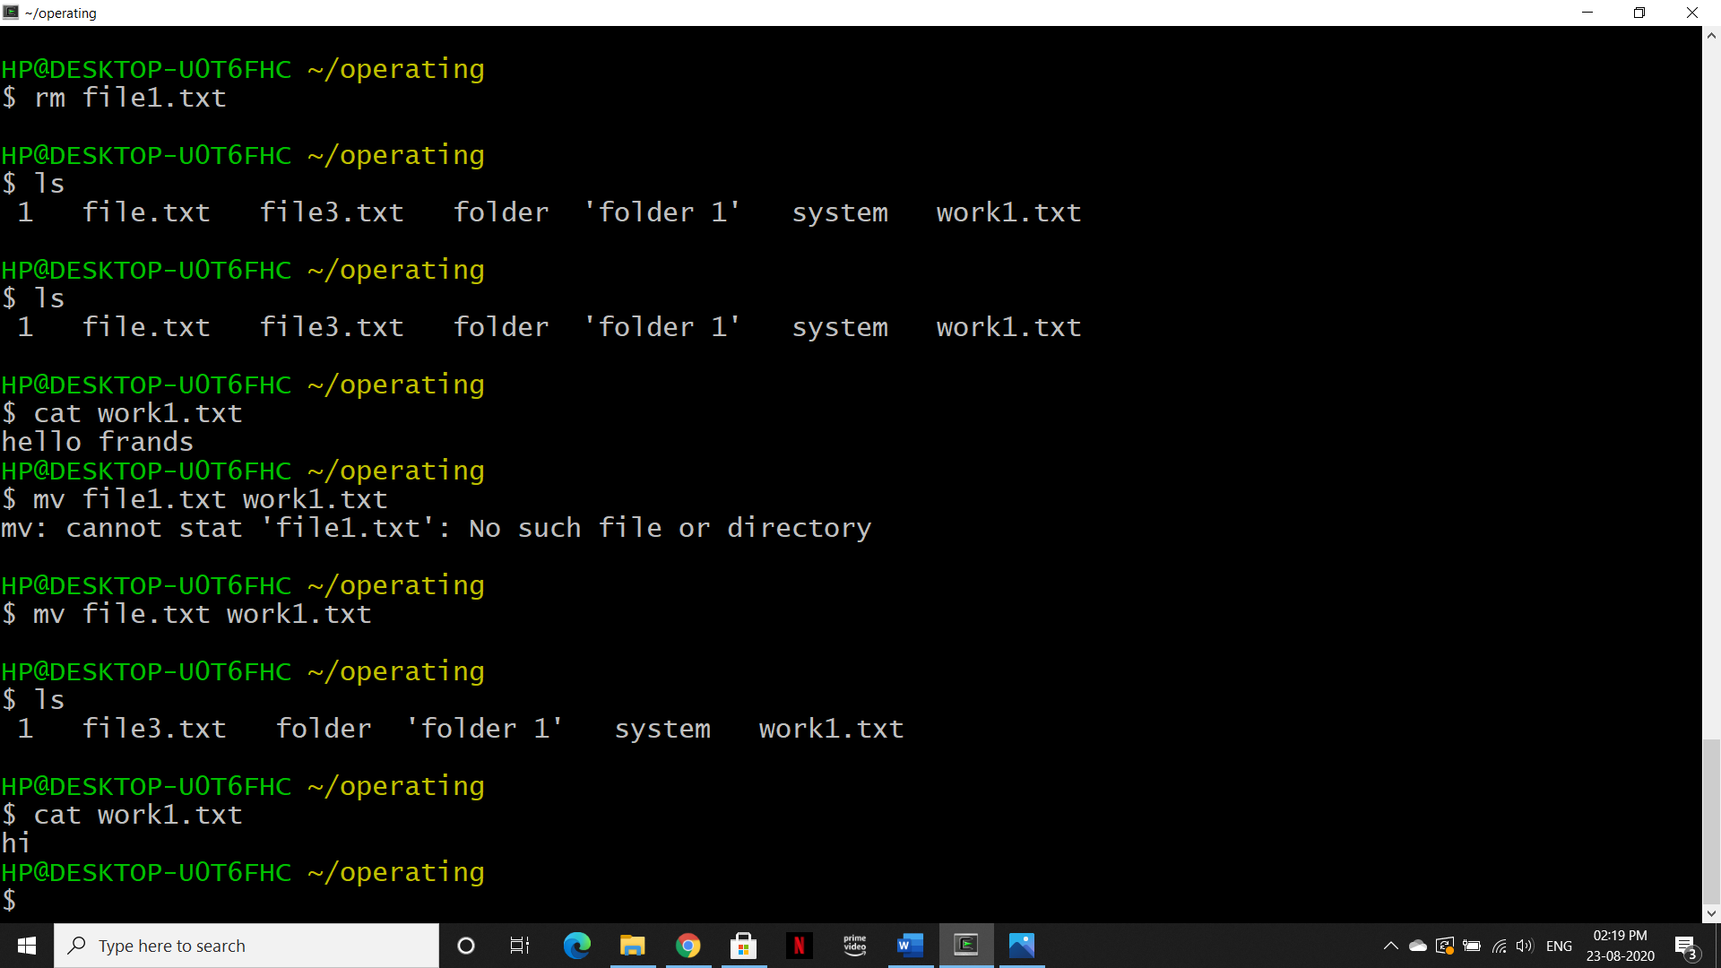

>file 1 contained “hi”



1. **rm:**

* **rm file-**

Description: It delete the file from directory

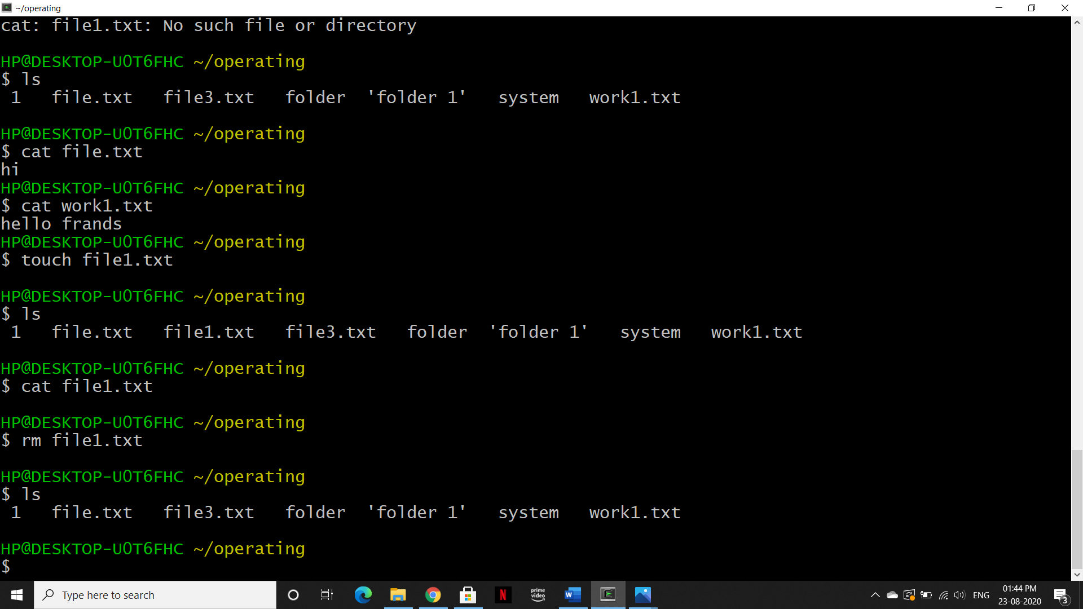

* **rm -r dir-**

Description: It delete the dir directory from current directory.

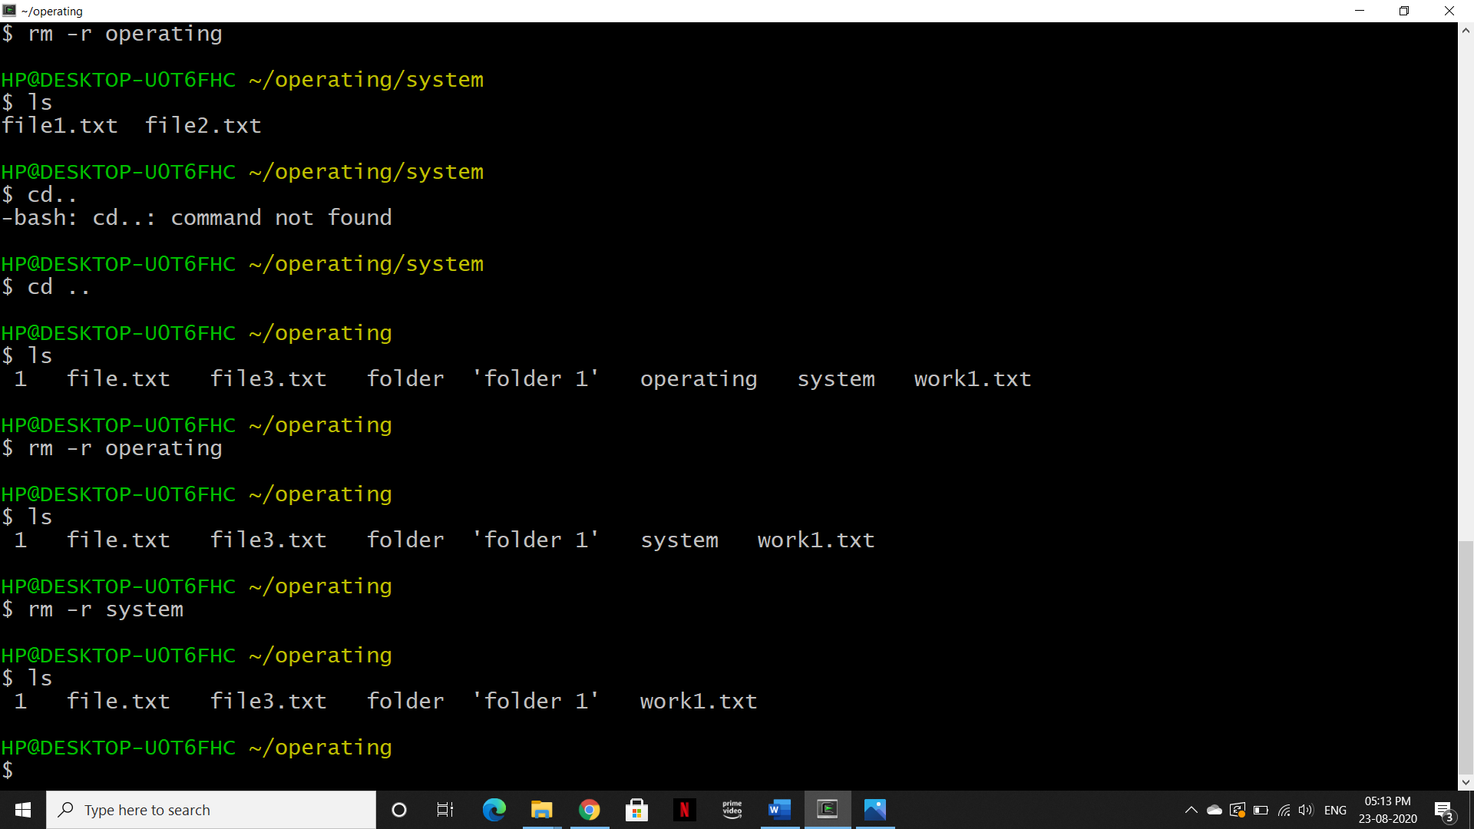

# **Process management**

1. **ps:**

**Description:** To display the currently working processes

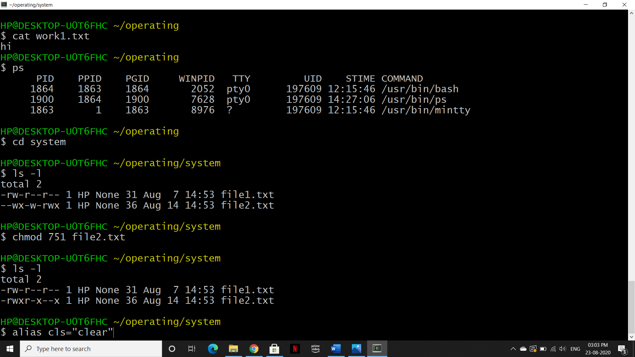

# **File permission**

1. **chmod:**

* **chmod octal file-**

Description: Change the permission of file to octal, which can be found separately for user, group, world by adding-

* 4-read(r)
  + 2-write(w)
  + 1-execute(x)
  + 0-no permission

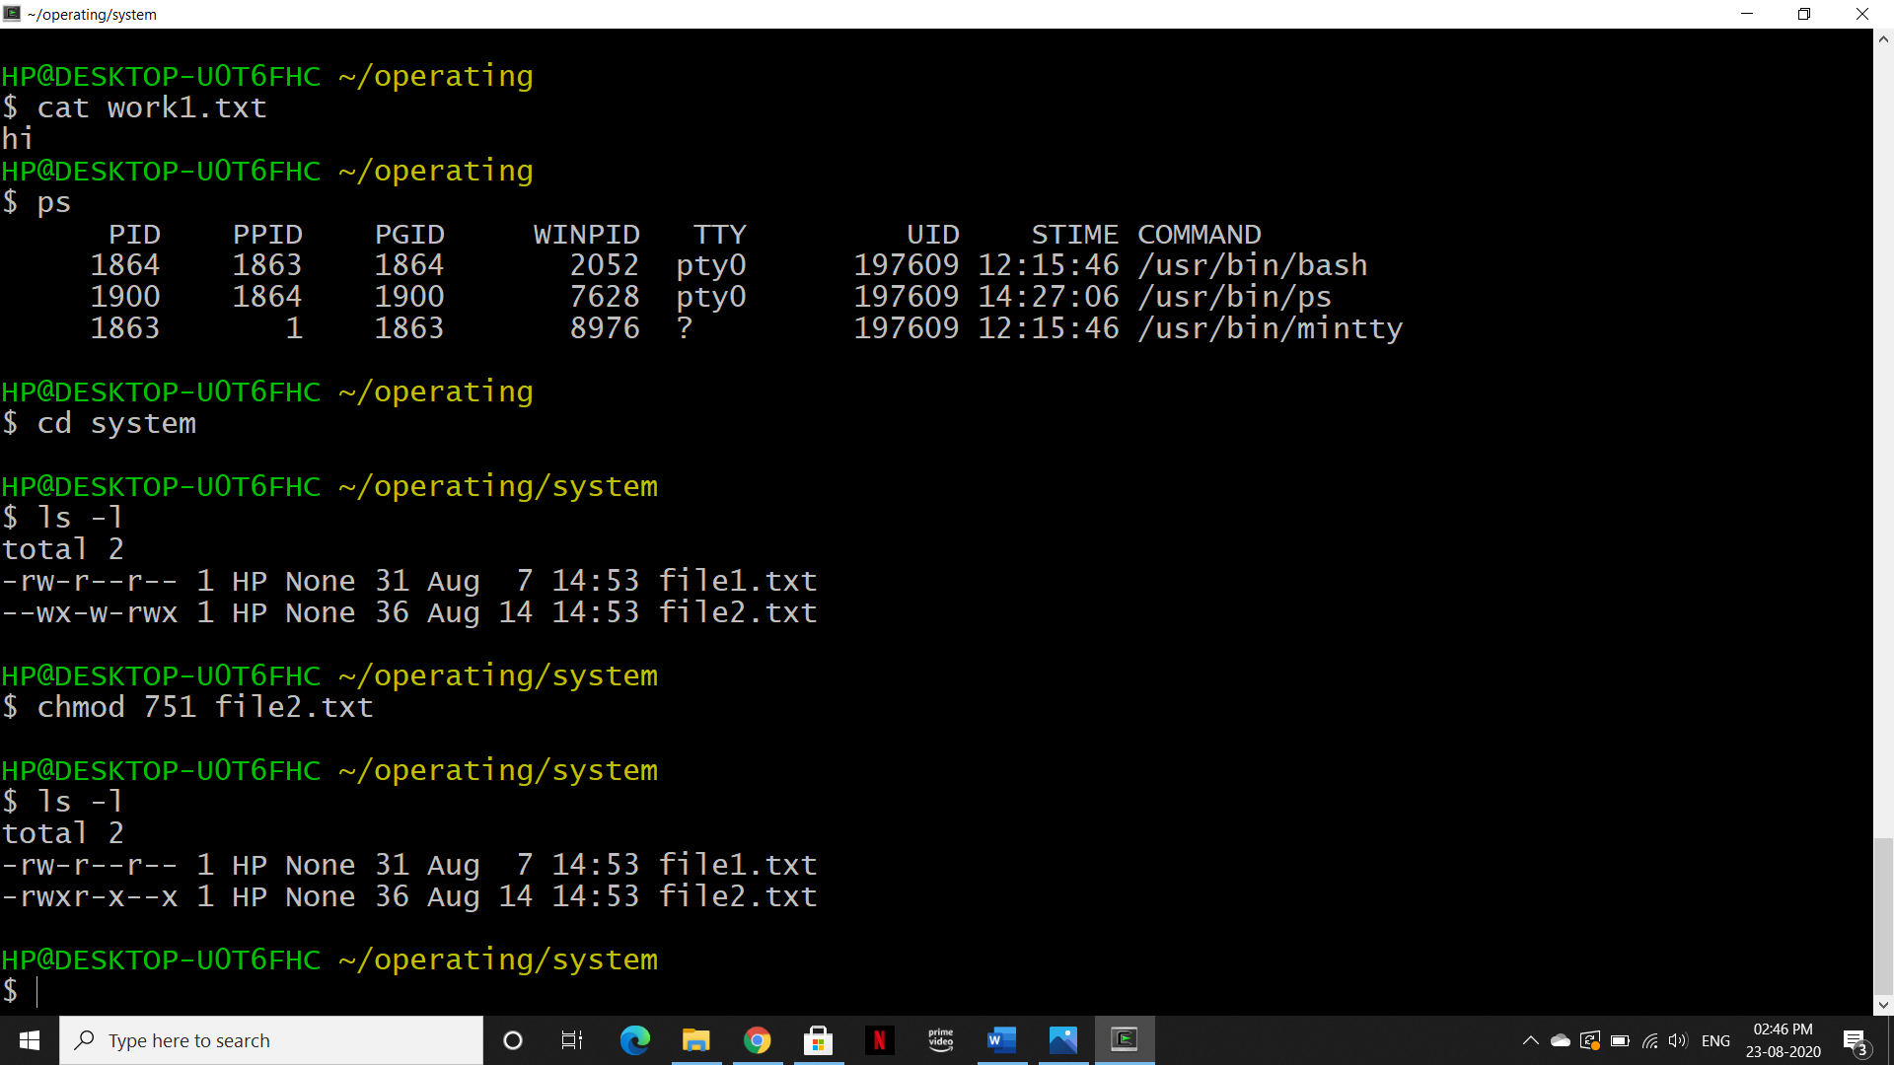

**Note:** Here the digits -7 represents to user, 5 represents to group and 1 represents to others and each digit is made from the numbers 4, 2, 1, and 0.

* **chmod [reference][operator][mode] filename-**

Reference operator mode

u (owner) + (Adds the specified modes to the specified classes) r(permission to read)

g (group) - ( Remove the specified modes to the specified classes) w(permission to write)

o ( others) x(permission to

execute)

a (all)

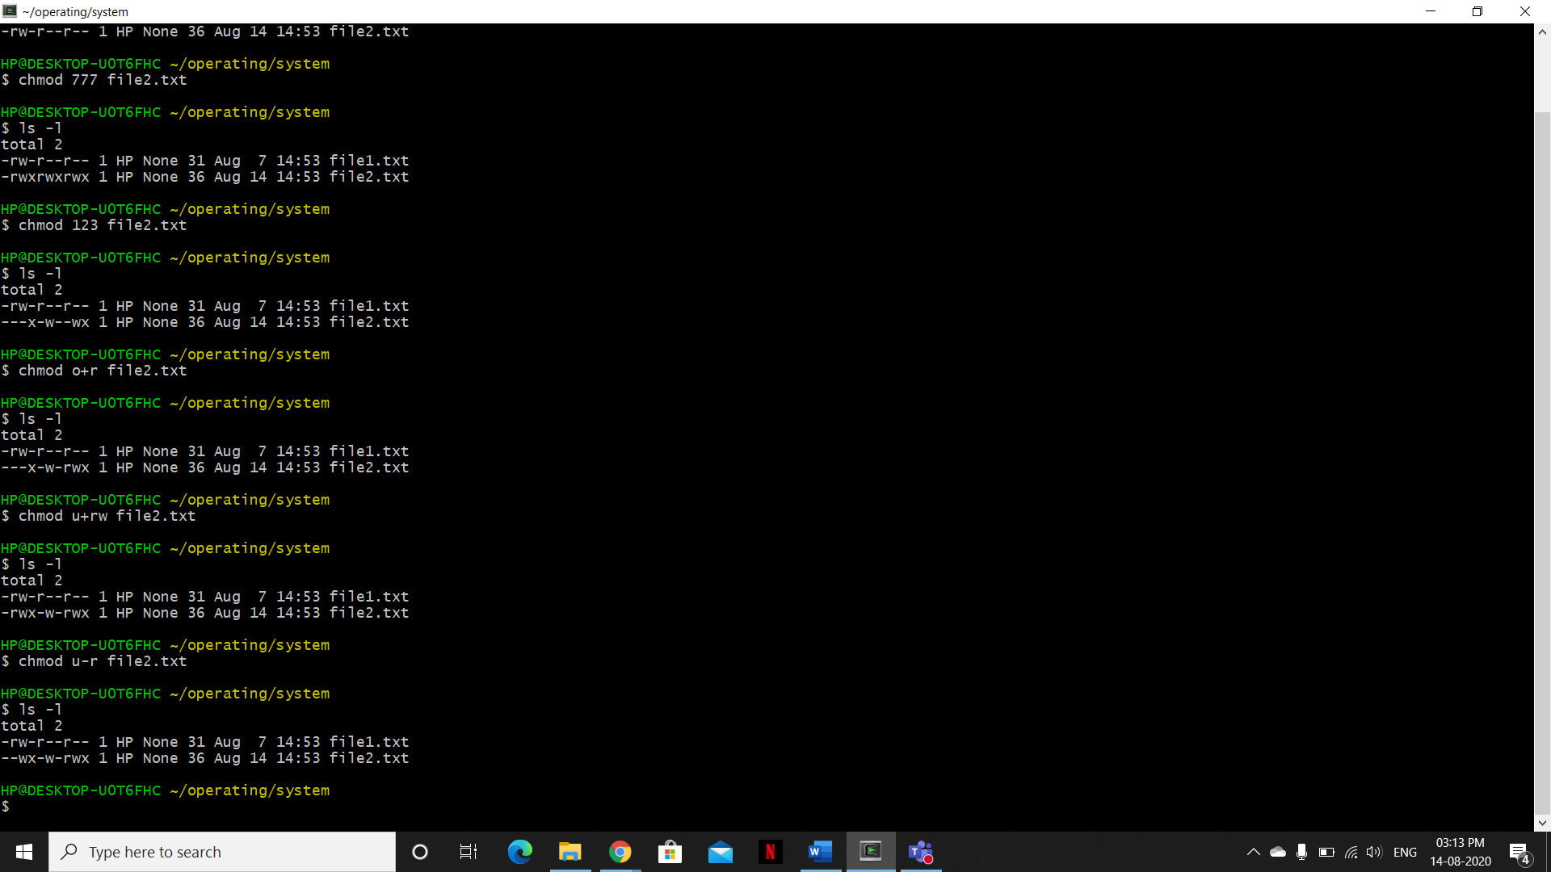

# **Searching**

1. **grep:**

* **grep pattern file**

Description: Search for pattern in file

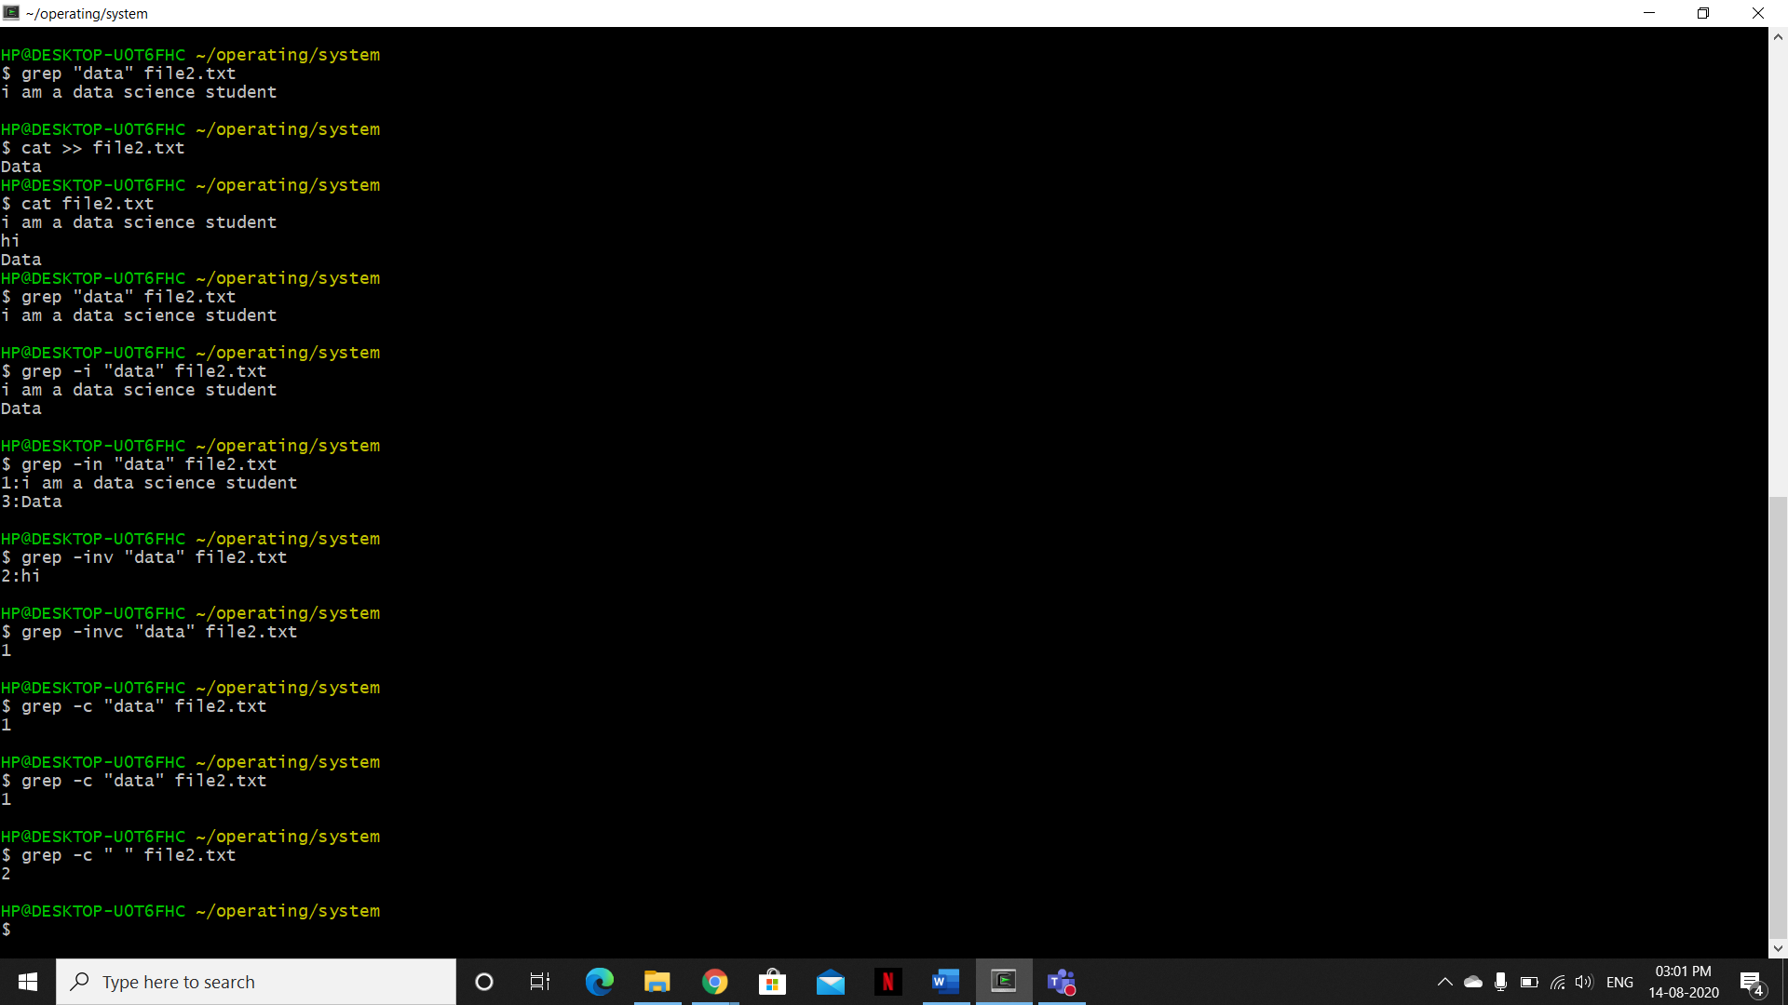

Note: In this case, grep is case sensitive

* **grep -i pattern file**

Description:Ignores, case of matching means it’s not case sensitive

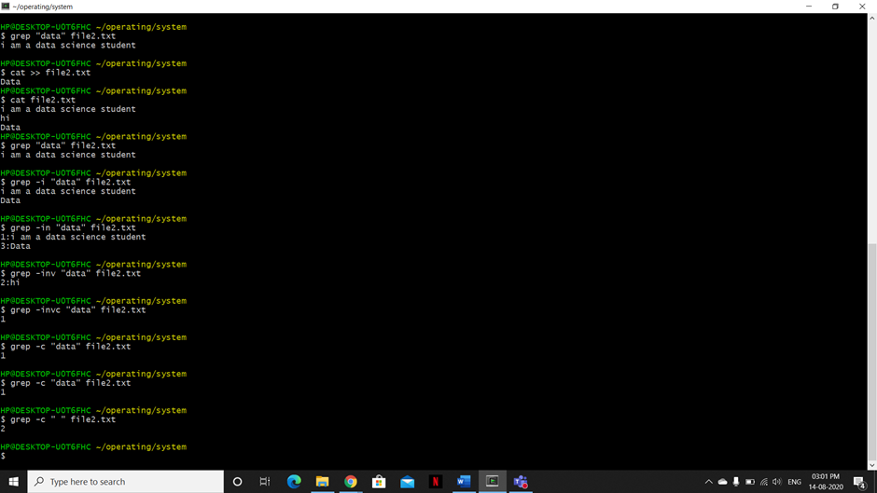

* **grep -n pattern file**

Description: Display the matched lines and their line number

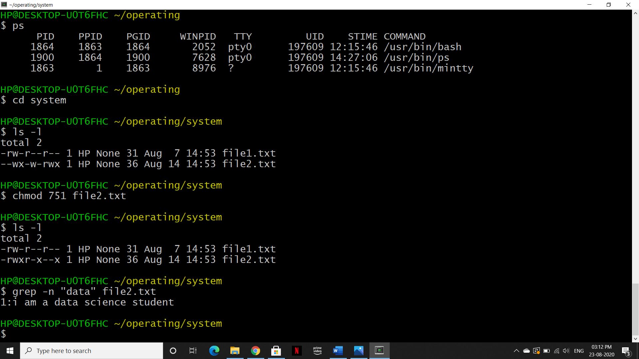

* **grep -v pattern file**

Description:This prints lines that don’t matches the pattern

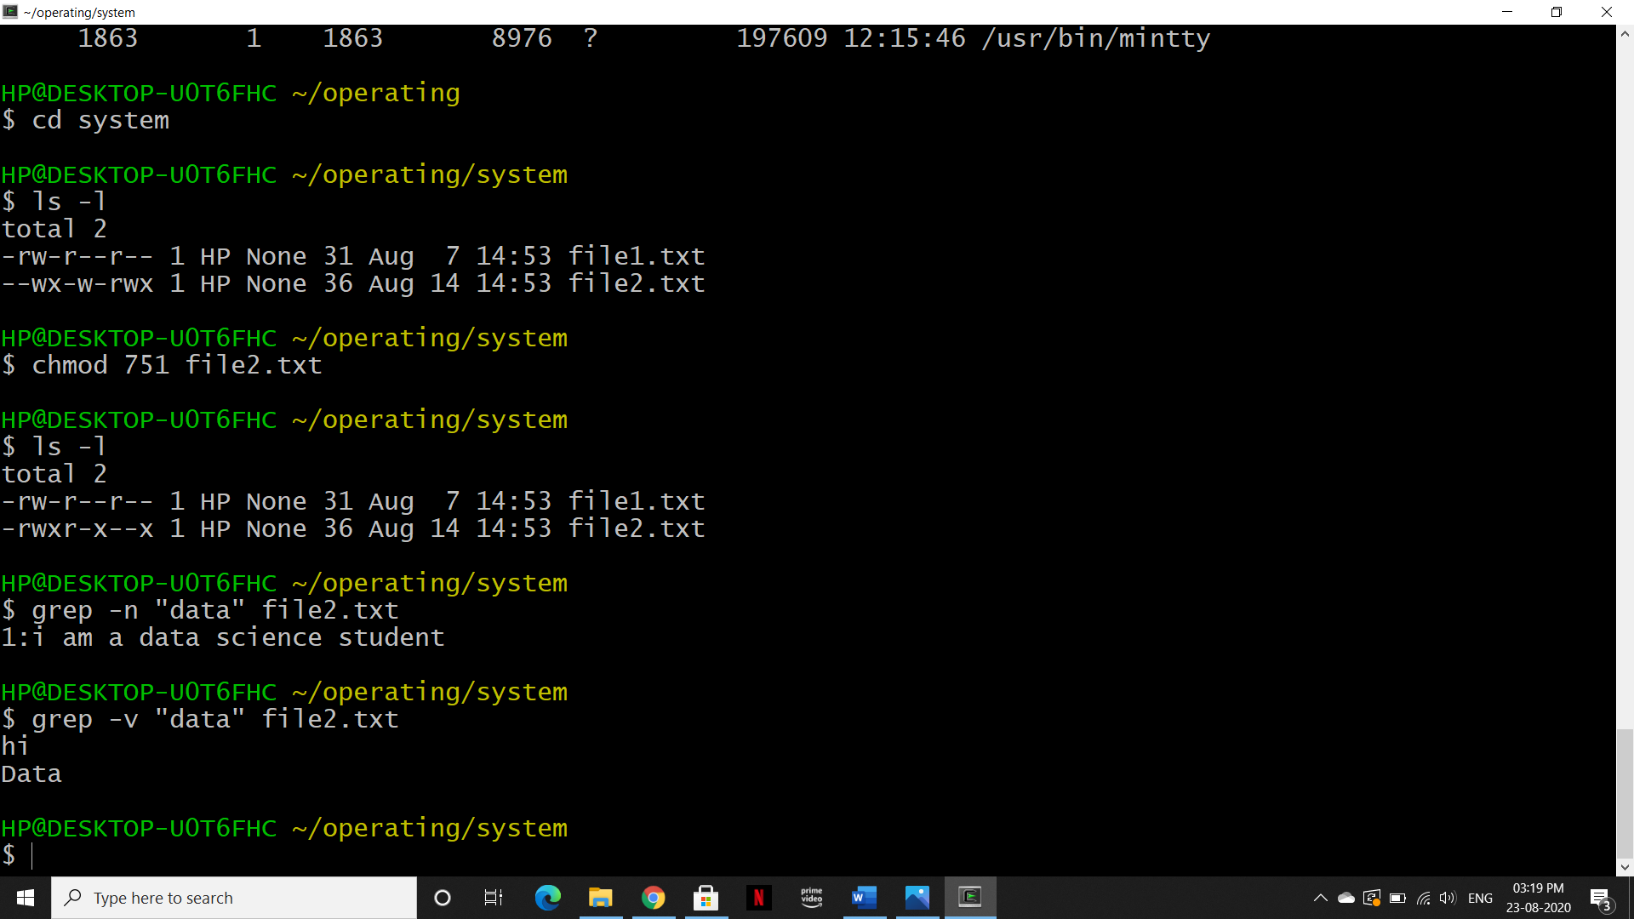

* **grep -c pattern file**

Description:This prints count of lines that matched the pattern



1. **find:**

Description: This command help us to find file of current or previous directory.

Syntax: $ find . -name filename

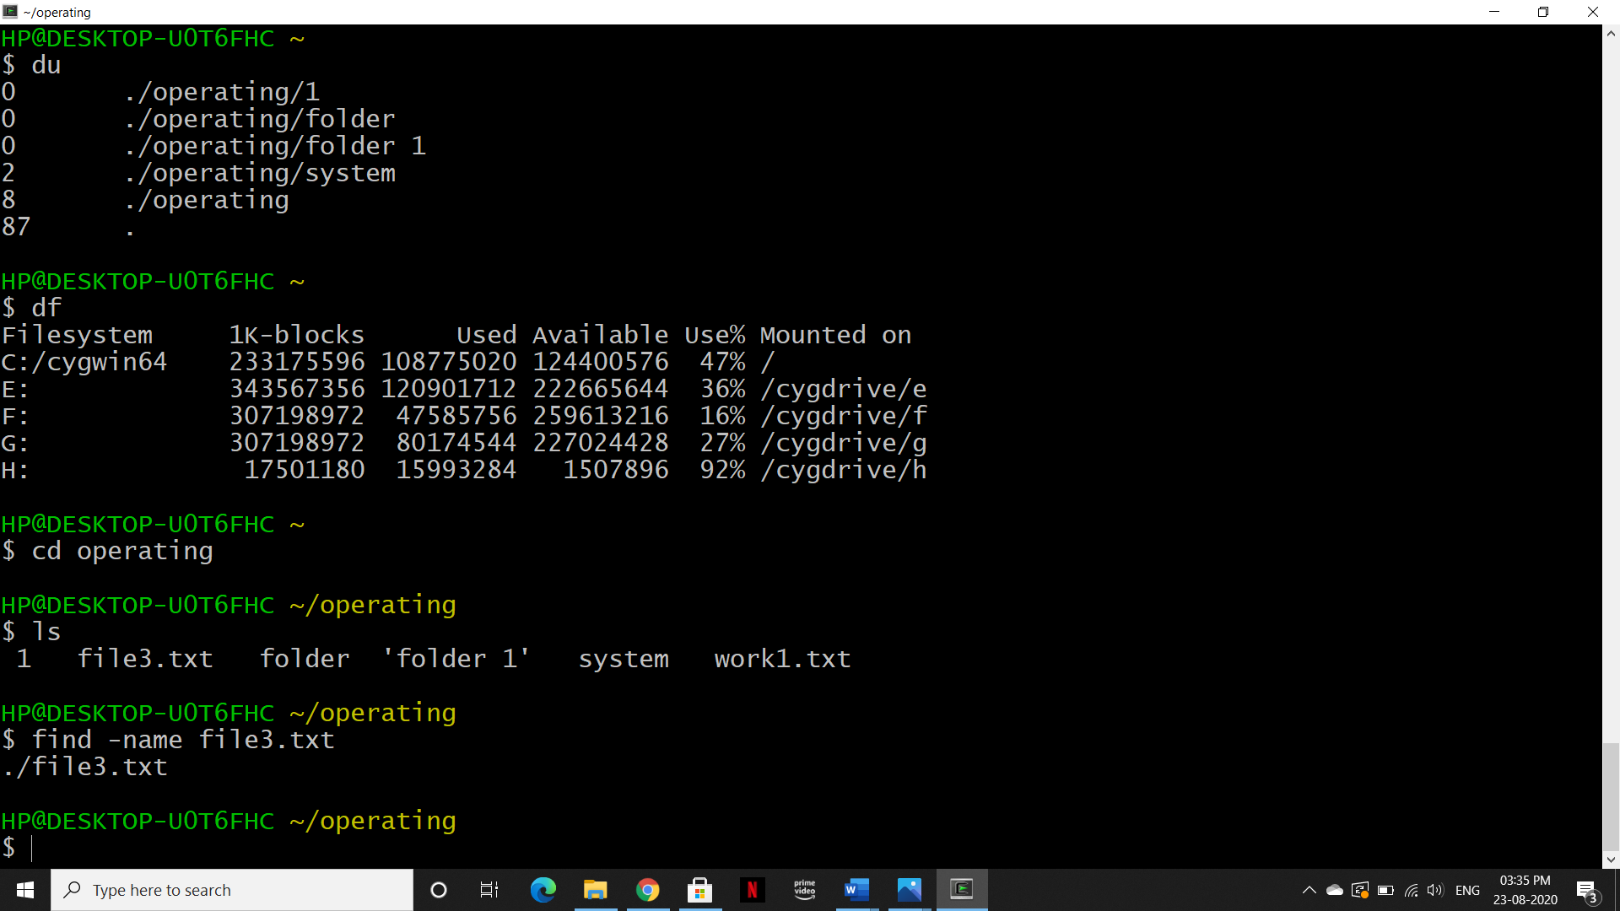

# **System Info**

1. **date:**

Description: Show the current date and time

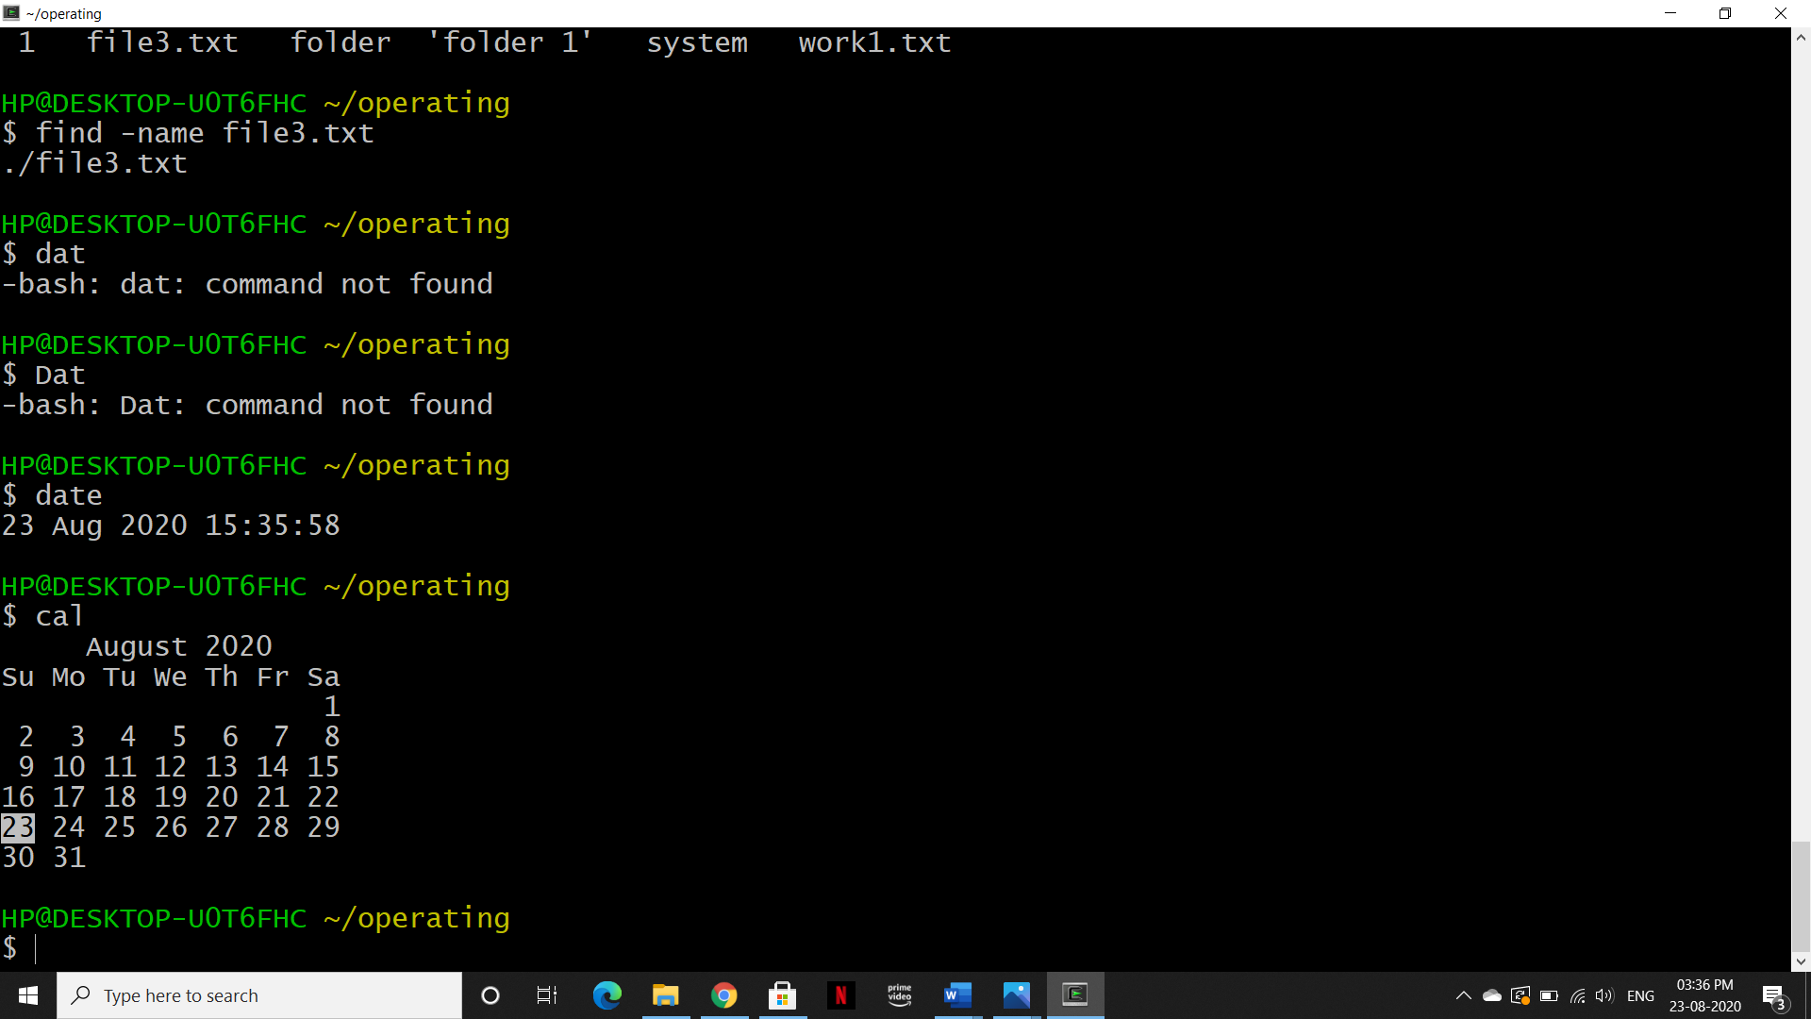

1. **cal**

Description: Show this month's calendar



1. **whoami:**

Description: Who you are logged in as

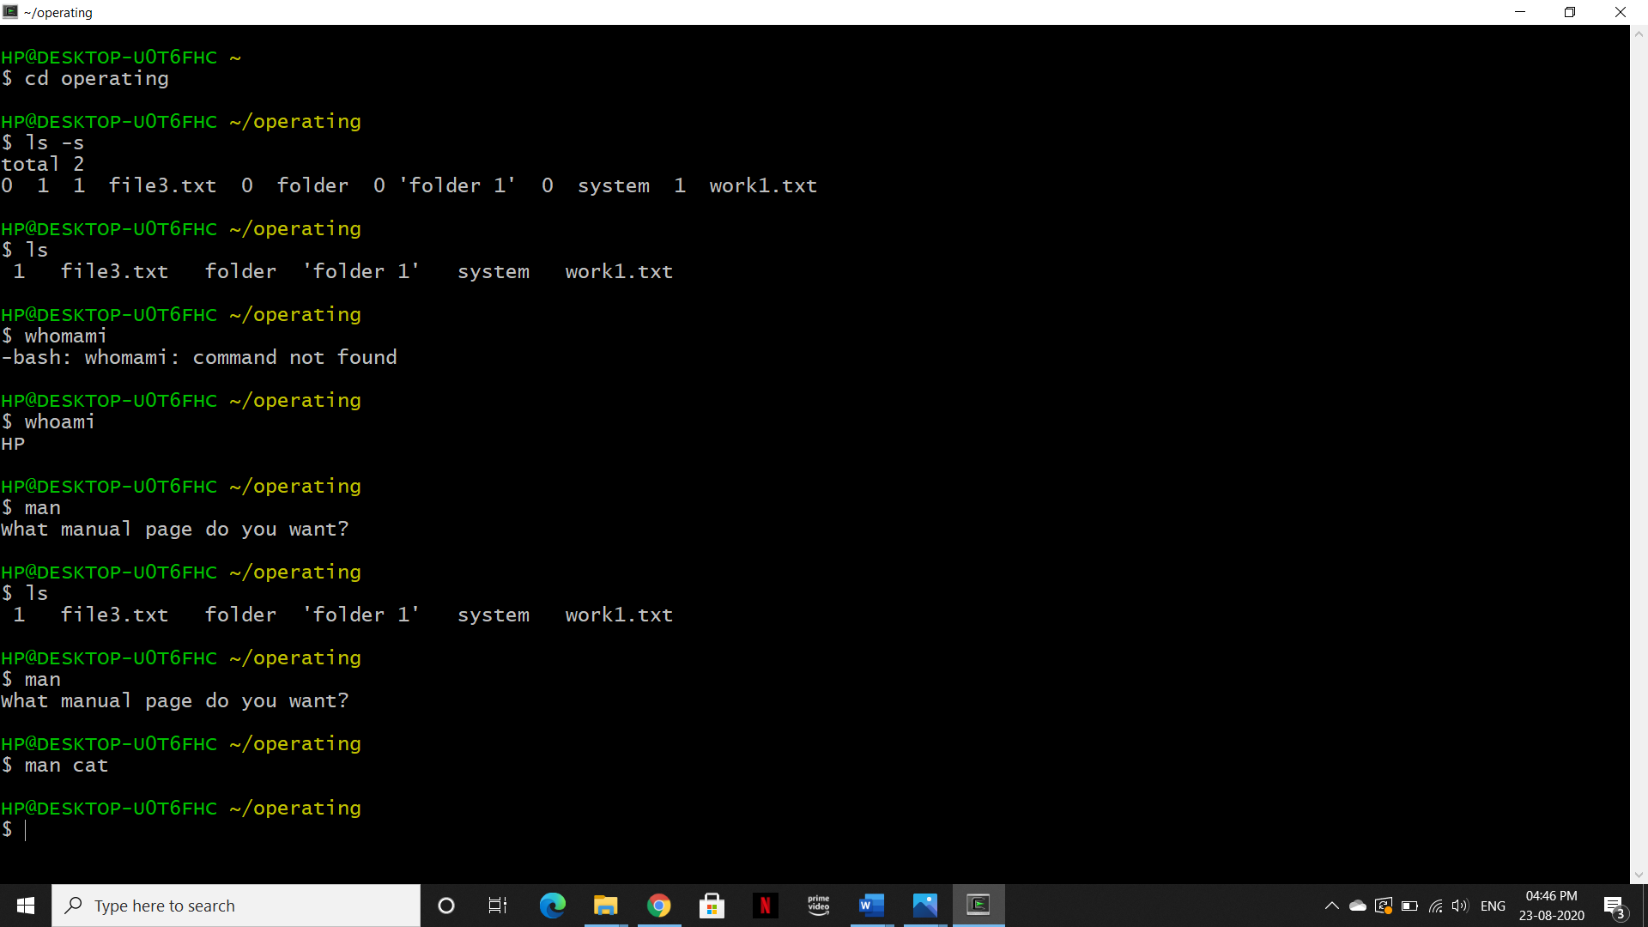

1. **df:**

Description: It shows the disk usage

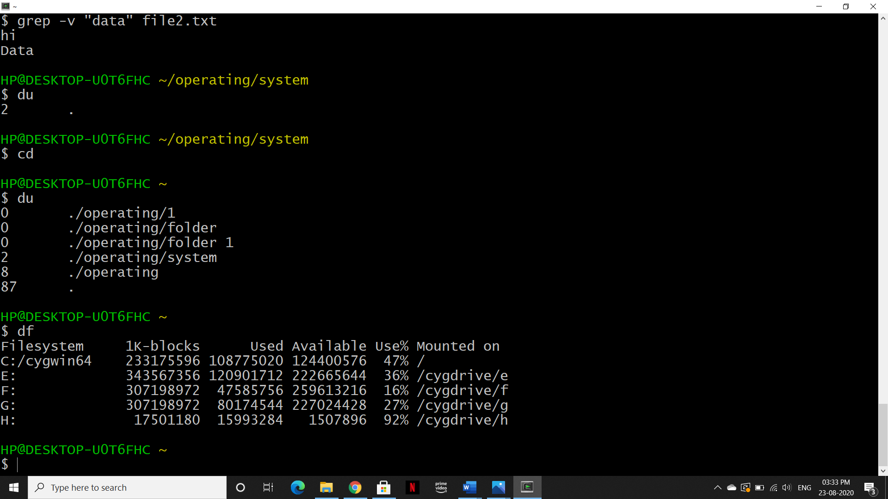

1. **du:**

Description: It shows directory space usage



1. **man:**

Description: This is a help book for commands

Syntax: man <command>



A dialog box will open-

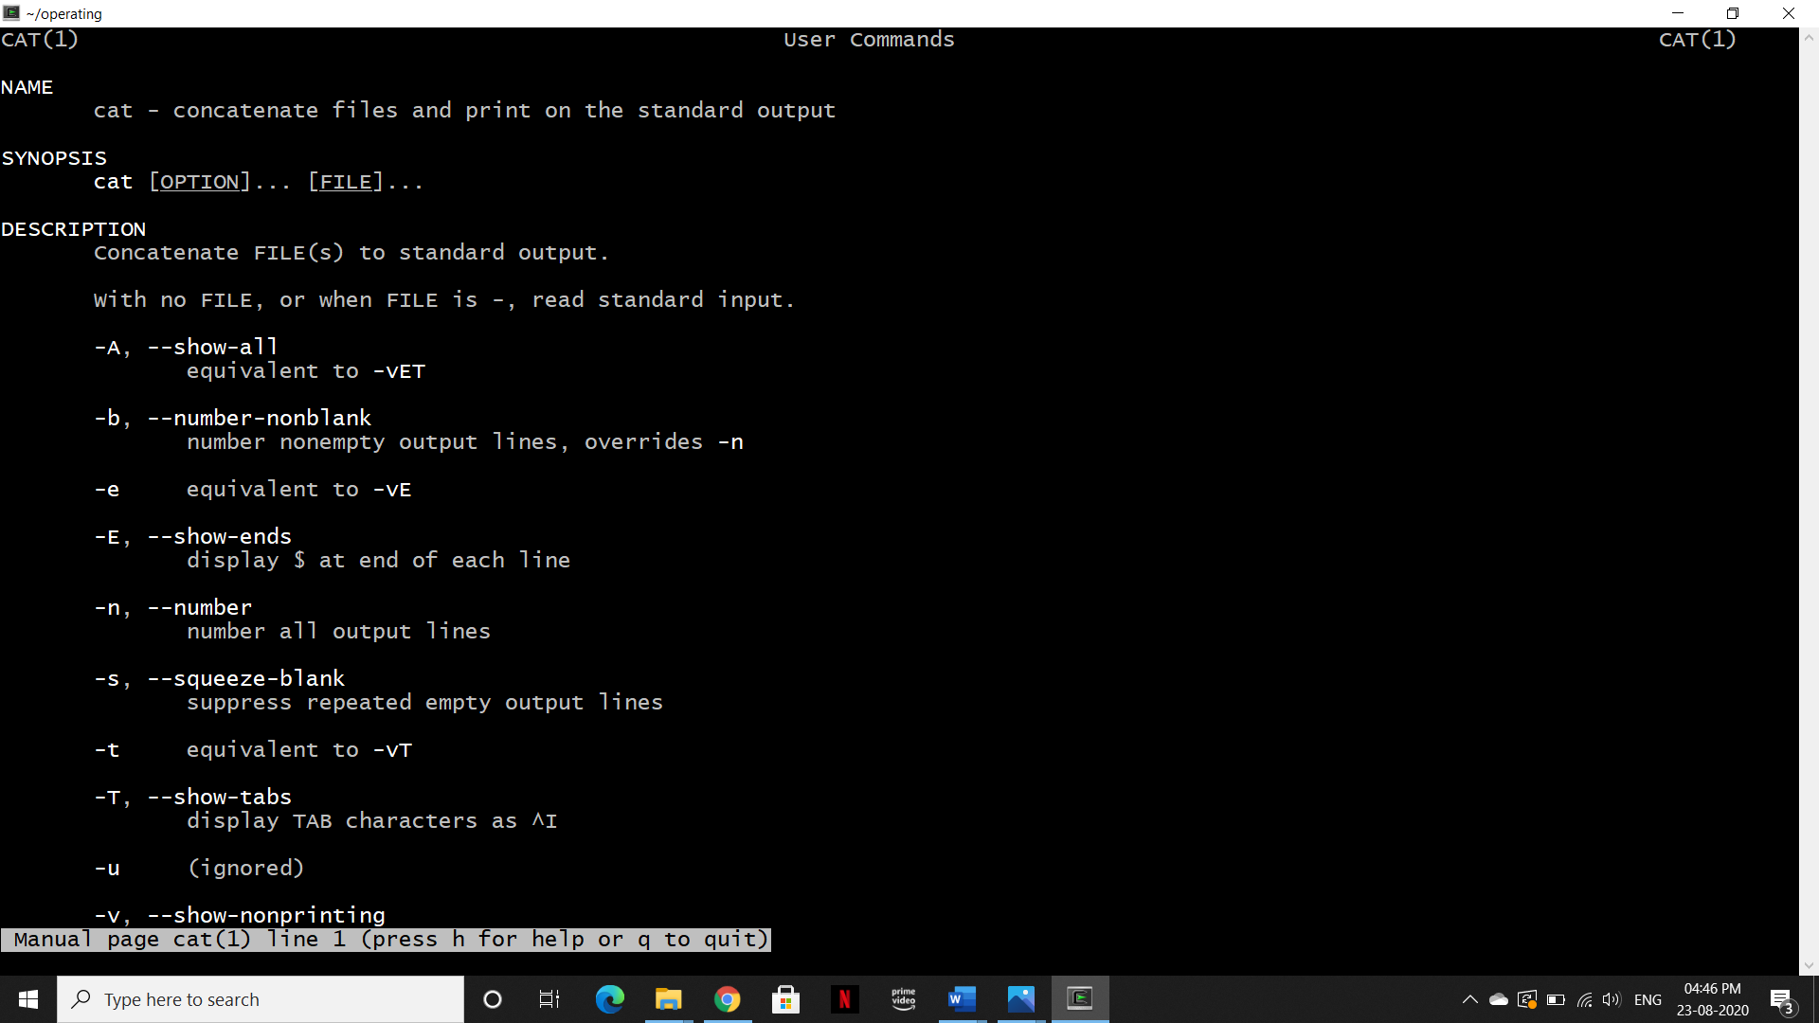

1. **Alias:**

Description: Used to change name of Linux commands



Note: If we use cls instead of clear command it will clear the whole screen

1. **echo:**

Description: This command print the string on the screen

